**Experiment 09- Using component diagrams to illustrate static implementation view**

**Learning Objective:** To understand how to use component diagrams to represent the static structure of a software system, including its components, interfaces, and relationships.

**Tools:**  Lucidchart

**Theory:** **Component Diagrams**: These diagrams provide a visual representation of the components within a system and their relationships. They illustrate how various components interact through interfaces, emphasizing the organization of the system.

**Key Concepts**:

* **Components**: Independent parts of the system that encapsulate a set of related functionalities.
* **Interfaces**: Specifications of the services that components provide or require, allowing for clear interaction points between components.
* **Connections**: Lines that represent the relationships between components, including required and provided interfaces.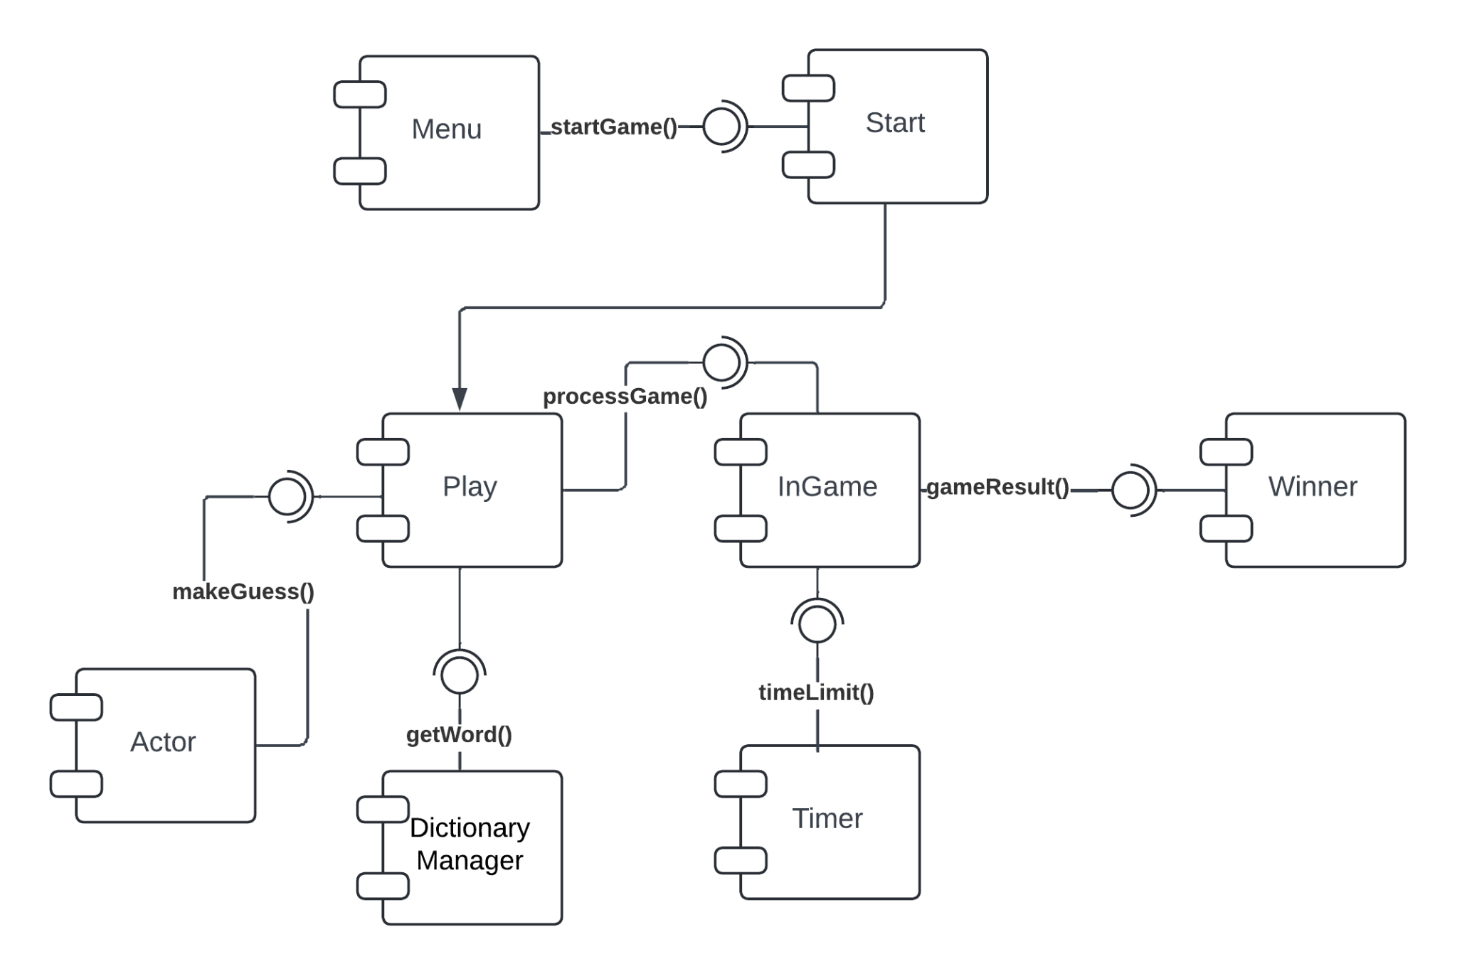

#### **Fig 1.** Component Diagram of Hangman Game

**Learning Outcomes:** The student should have the ability to:

**LO 1**: Create component diagrams using Lucidchart to represent the static implementation of software systems.

**LO 2**: Identify and define the key components and their interfaces within a system architecture.

**LO 3**: Analyze and explain the relationships between components and how they interact through provided and required interfaces.

**Course Outcomes:** Upon completion of the course, students will be equipped to understand and articulate fundamental concepts of software architecture and design patterns. They will learn how to effectively use component diagrams to model software systems, identify key components and their interactions, and apply best practices for designing and documenting system architectures. This knowledge will empower students to contribute to the development of robust and maintainable software solutions.

**Conclusion:**

**For Faculty Use**

| **Correction Parameters** | **Formative Assessment [40%]** | **Timely completion of Practical [ 40%]** | **Attendance / Learning Attitude [20%]** | **Total** |
| --- | --- | --- | --- | --- |
| **Marks Obtained** |  |  |  |  |